housing2.ipynb Carga datos (10 columnas/campos)
# 1 %% abrir librerías
import pandas as pd
from sklearn.impute import SimpleImputer
import numpy as np
from sklearn.model_selection import train_test_split
from sklearn.preprocessing import StandardScaler
from sklearn.linear_model import LinearRegression
from sklearn.tree import DecisionTreeRegressor
from sklearn.ensemble import RandomForestRegressor
from sklearn.ensemble import GradientBoostingRegressor
# You might also need these for regression:
from sklearn.metrics import mean_squared_error, r2_score
2 %% Cargar datos Load tge data
url = 'https://raw.githubusercontent.com/emadrigals104/PLFPython/main/Datasets/housing.csv'
df = pd.read_csv(url)
print(df.head(5))
longitude latitude housing_median_age total_rooms total_bedrooms \
0 -122.23 37.88 41.0 880.0 129.0
1 -122.22 37.86 21.0 7099.0 1106.0
2 -122.24 37.85 52.0 1467.0 190.0
3 -122.25 37.85 52.0 1274.0 235.0
4 -122.25 37.85 52.0 1627.0 280.0

population households median_income median_house_value ocean_proximity
0 322.0 126.0 8.3252 452600.0 NEAR BAY
1 2401.0 1138.0 8.3014 358500.0 NEAR BAY
2 496.0 177.0 7.2574 352100.0 NEAR BAY
3 558.0 219.0 5.6431 341300.0 NEAR BAY
4 565.0 259.0 3.8462 342200.0 NEAR BAY
# 3 %% Handle missing values
imputer = SimpleImputer(strategy='median')
df['total_bedrooms'] = imputer.fit_transform(df[['total_bedrooms']])
print(df.isnull().sum())
longitude 0
latitude 0
housing_median_age 0
total_rooms 0
total_bedrooms 0
population 0
households 0
median_income 0
median_house_value 0
ocean_proximity 0
dtype: int64
# 4 %%Convert categorical variable
df = pd.get_dummies(df, columns=['ocean_proximity'])
# 5 Print def(head)
print(df.head())
longitude latitude housing_median_age total_rooms total_bedrooms \
0 -122.23 37.88 41.0 880.0 129.0
1 -122.22 37.86 21.0 7099.0 1106.0
2 -122.24 37.85 52.0 1467.0 190.0
3 -122.25 37.85 52.0 1274.0 235.0
4 -122.25 37.85 52.0 1627.0 280.0
population households median_income median_house_value \
0 322.0 126.0 8.3252 452600.0
1 2401.0 1138.0 8.3014 358500.0
2 496.0 177.0 7.2574 352100.0
3 558.0 219.0 5.6431 341300.0
4 565.0 259.0 3.8462 342200.0
ocean_proximity_<1H OCEAN ocean_proximity_INLAND ocean_proximity_ISLAND \
0 False False False
1 False False False
2 False False False
3 False False False
4 False False False
ocean_proximity_NEAR BAY ocean_proximity_NEAR OCEAN
0 True False
1 True False
2 True False
3 True False
4 True False
# 6 Separate features and Target
X = df.drop('median_house_value', axis=1)
y = df['median_house_value']
# 7 Split data into training and testing sets
X_train, X_test, y_train, y_test = train_test_split(X, y, test_size=0.2, random_state=42)
# 8. Scale the data
scaler = StandardScaler()
X_train_scaled = scaler.fit_transform(X_train)
X_test_scaled = scaler.transform(X_test)
# 9 Create a diccionary of models
models = {
'Linear Regression': LinearRegression(),
'Decision Tree': DecisionTreeRegressor(random_state=42),
'Random Forest': RandomForestRegressor(random_state=42),
'Gradient Boosting': GradientBoostingRegressor(random_state=42)
}
# 10. Train and evaluate each model
for name, model in models.items():
# Train the model
model.fit(X_train_scaled, y_train)

# Make predictions on the training data
y_pred_train = model.predict(X_train_scaled)

# Calculate the root mean squared error (RMSE)
rmse_train = np.sqrt(mean_squared_error(y_train, y_pred_train))

print(f"Model: {name}")
print(f"Training RMSE: {rmse_train:.2f}")
print("-" * 30)
import matplotlib.pyplot as plt
import numpy as np

Model: Linear Regression
Training RMSE: 68433.94
------------------------------
Model: Decision Tree
Training RMSE: 0.00
------------------------------
Model: Random Forest
Training RMSE: 18073.21
------------------------------
Model: Gradient Boosting
Training RMSE: 52901.31
# 10 %% Evaluate models on the test set and visualize the results
import matplotlib.pyplot as plt

for name, model in models.items():
# Make predictions on the test data
y_pred_test = model.predict(X_test_scaled)

# Calculate the root mean squared error (RMSE) on the test data
rmse_test = np.sqrt(mean_squared_error(y_test, y_pred_test))

# Print the test RMSE
print(f"Model: {name}")
print(f"Test RMSE: {rmse_test:.2f}")

# Create a scatter plot
plt.figure(figsize=(10, 6))
plt.scatter(y_test, y_pred_test, alpha=0.5)
plt.plot([y_test.min(), y_test.max()], [y_test.min(), y_test.max()], 'r--', lw=2)
plt.xlabel("Actual Values")
plt.ylabel("Predicted Values")
plt.title(f"{name} - Actual vs. Predicted Values (Test Set)")
plt.grid(True)
plt.show()

print("-" * 30)
Model: Linear Regression
Test RMSE: 70060.62
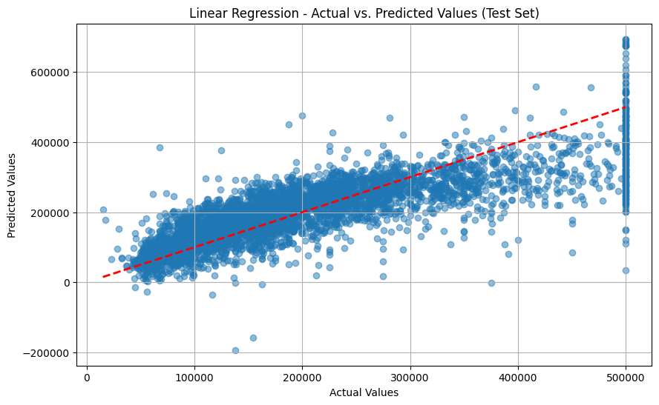
Ver resto en C:\Users\ACER\PYTHON COURSES\Python Machine Learning\housing project

ml6getdb.py
import pandas as pd
from sklearn.ensemble import RandomForestRegressor
from sklearn.model_selection import train_test_split
from sklearn.metrics import mean_absolute_error

# 1. Cargar los datos (usando el DataFrame que ya tienes de la web)
url = "https://raw.githubusercontent.com/ageron/handson-ml2/master/datasets/housing/housing.csv"
df = pd.read_csv(url)
print(df.head())
# 2. FEATURE ENGINEERING: Creamos columnas más inteligentes
df["rooms_per_household"] = df["total_rooms"] / df["households"]
df["population_per_household"] = df["population"] / df["households"]
# 3. Limpieza: Llenamos nulos para que el modelo no falle
df['total_bedrooms'] = df['total_bedrooms'].fillna(df['total_bedrooms'].median())
# 4. Seleccionamos las nuevas variables + las mejores anteriores
features = ['median_income', 'rooms_per_household', 'population_per_household', 'housing_median_age']
X = df[features]
y = df['median_house_value']

# 5. Dividir y Entrenar
X_train, X_test, y_train, y_test = train_test_split(X, y, test_size=0.2, random_state=42)
modelo_final = RandomForestRegressor(n_estimators=100, random_state=42)
modelo_final.fit(X_train, y_train)

# 6. Evaluación
error = mean_absolute_error(y_test, modelo_final.predict(X_test))
print(f"Nuevo Error promedio (MAE) con variables optimizadas: ${error:,.2f}")

import joblib
# 1. Definir el nombre del archivo (Viviendas es REGRESIÓN, no clasificación)
nombre_archivo = 'modelo_viviendas_rf.pkl'
try:
# 2. Guardar el modelo que acabas de entrenar (modelo_final)
joblib.dump(modelo_final, nombre_archivo)
print(f"Modelo guardado exitosamente como: {nombre_archivo}")
except NameError:
print("Error: La variable 'modelo_final' no existe. Revisa el nombre del modelo entrenado arriba.")
except Exception as e:
print(f"Ocurrió un error inesperado: {e}")

ml7getdb.py. Uso del modelo
import joblib
import pandas as pd
# 1. Cargar el modelo
nombre_archivo = 'modelo_viviendas_rf.pkl'
modelo_cargado = joblib.load(nombre_archivo)
# 2. Definir los datos nuevos
columnas = ['median_income', 'rooms_per_household', 'population_per_household', 'housing_median_age']
datos_nuevos = pd.DataFrame([[4.5, 6.2, 2.8, 35]], columns=columnas)
# 3. Predecir
prediccion = modelo_cargado.predict(datos_nuevos)
# 4. Imprimir el resultado (SIN EMOJIS para evitar el error de Unicode)
print("--- Resultado de la Prediccion ---")
print(f"El valor estimado de la propiedad es: ${prediccion[0]:,.2f}")

ml6_mejorado.py
import pandas as pd
import joblib
from sklearn.ensemble import RandomForestRegressor
from sklearn.model_selection import train_test_split

# 1. Carga de datos
url = "https://raw.githubusercontent.com/ageron/handson-ml2/master/datasets/housing/housing.csv"
df = pd.read_csv(url)
# 2. Limpieza y Feature Engineering
df['total_bedrooms'] = df['total_bedrooms'].fillna(df['total_bedrooms'].median())
df["rooms_per_household"] = df["total_rooms"] / df["households"]

# 3. Seleccionamos Latitud y Longitud como variables CLAVE
features = ['longitude', 'latitude', 'median_income', 'rooms_per_household', 'housing_median_age']
X = df[features]
y = df['median_house_value']
# 4. Entrenamiento
X_train, X_test, y_train, y_test = train_test_split(X, y, test_size=0.2, random_state=42)
modelo_geo = RandomForestRegressor(n_estimators=100, random_state=42)
modelo_geo.fit(X_train, y_train)

# 5. Guardar el nuevo modelo
joblib.dump(modelo_geo, 'modelo_viviendas_geo.pkl')
print("✅ Nuevo modelo guardado como 'modelo_viviendas_geo.pkl' con datos geográficos.")

ml6_mejUso.py
import streamlit as st
import joblib
import pandas as pd

# Cargar el nuevo modelo
modelo = joblib.load('modelo_viviendas_geo.pkl')

st.title("📍 Predicción Inmobiliaria Geográfica")
# Sidebar
st.sidebar.header("Ubicación y Datos")
# Rangos reales de California
lat = st.sidebar.slider("Latitud", 32.5, 42.0, 37.8)
lon = st.sidebar.slider("Longitud", -124.3, -114.3, -122.2)
ingreso = st.sidebar.slider("Ingreso Medio", 0.5, 15.0, 4.0)
rooms = st.sidebar.slider("Habitaciones", 1.0, 10.0, 5.0)
edad = st.sidebar.slider("Edad Casa", 1, 52, 30)

# Predicción
input_df = pd.DataFrame([[lon, lat, ingreso, rooms, edad]],
columns=['longitude', 'latitude', 'median_income', 'rooms_per_household', 'housing_median_age'])
prediccion = modelo.predict(input_df)[0]

# Resultados
col1, col2 = st.columns(2)
with col1:
st.metric("Precio Estimado", f"${prediccion:,.2f}")
with col2:
# Mostrar el punto exacto en el mapa
punto_mapa = pd.DataFrame({'lat': [lat], 'lon': [lon]})
st.map(punto_mapa, zoom=5)
st.write(f"Coordenadas actuales: {lat}, {lon}")

OJO

